
Observer Report
Created on Wednesday, 19 April 2023 4:36:30 PM
Production Information
Shotpoints Acquired Today
1172
Aborted Shots/Sweeps
0
First Shot
19/04/2023 7:57:54 AM UTC +10 hours
Last Shot
19/04/2023 4:31:03 PM UTC +10 hours
Production Time
8 hours 33 minutes
Total Acquired
710
Planned Shots
5732
Remaining Shots
5022
Today's Acquisition Speed
136 Shotpoints/Hour
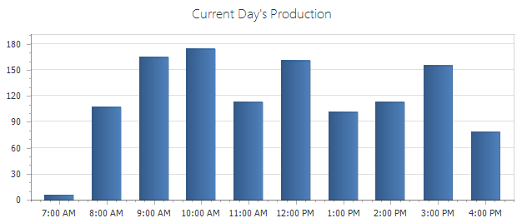
Production
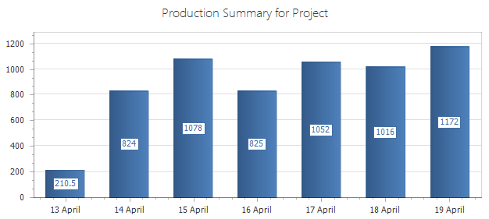
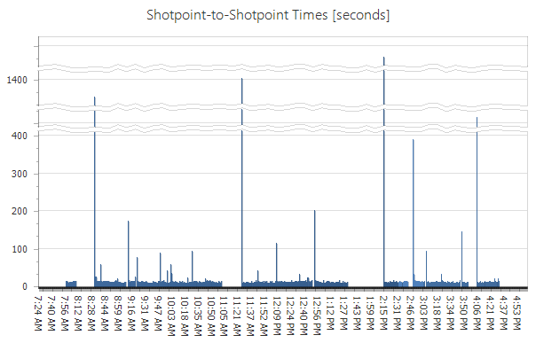
Overhead and Downtime
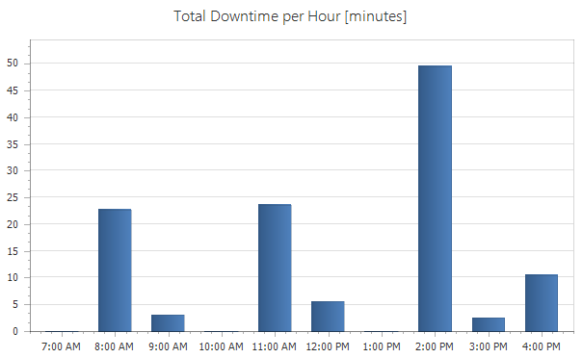
Area Map
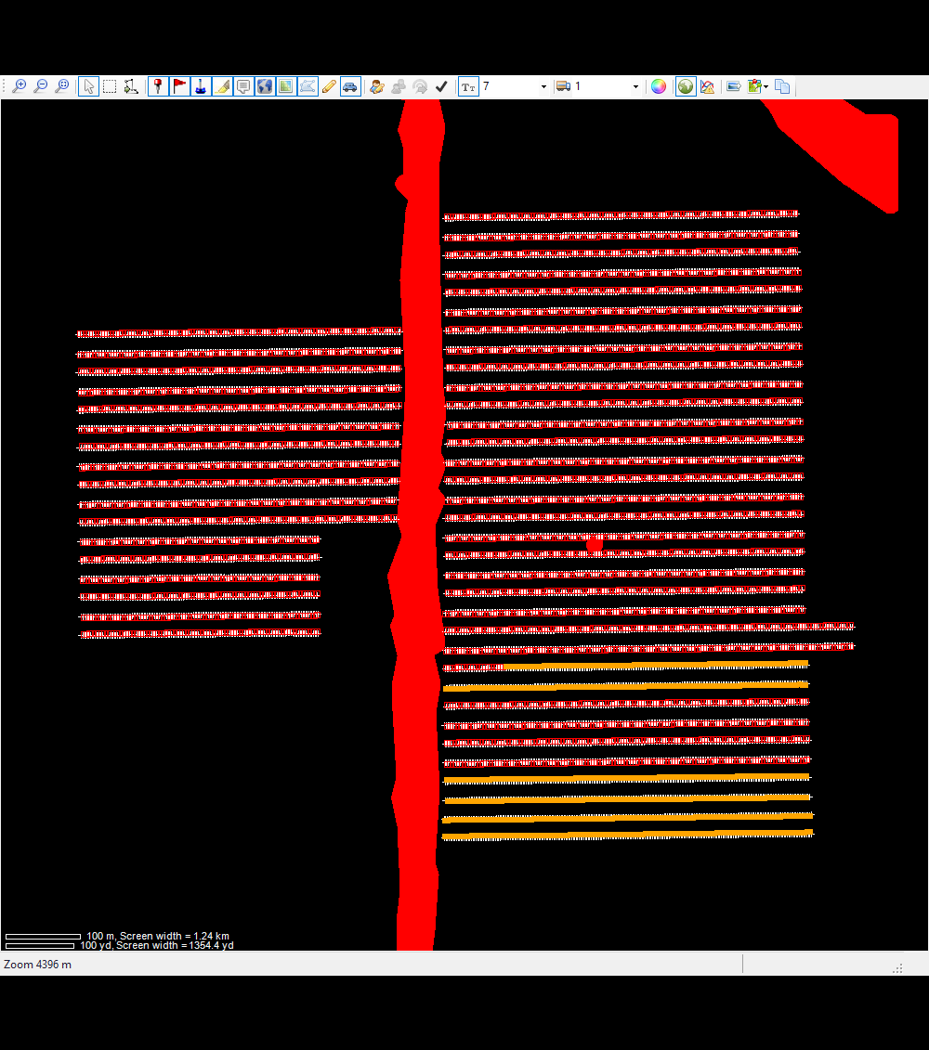
List of Source Decoders
Group
Unit
Type
Driver/Shooter
1
7
Force Three

Vibrator Error Summary
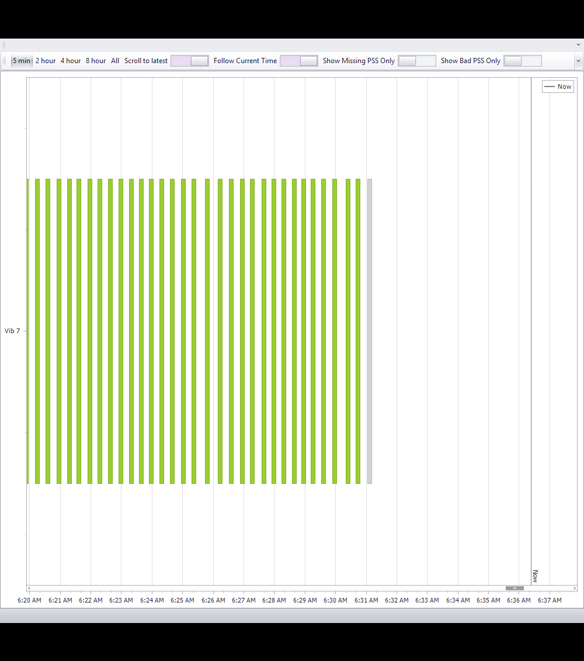
Vibrator PSS Information
PSS Geographical Representation
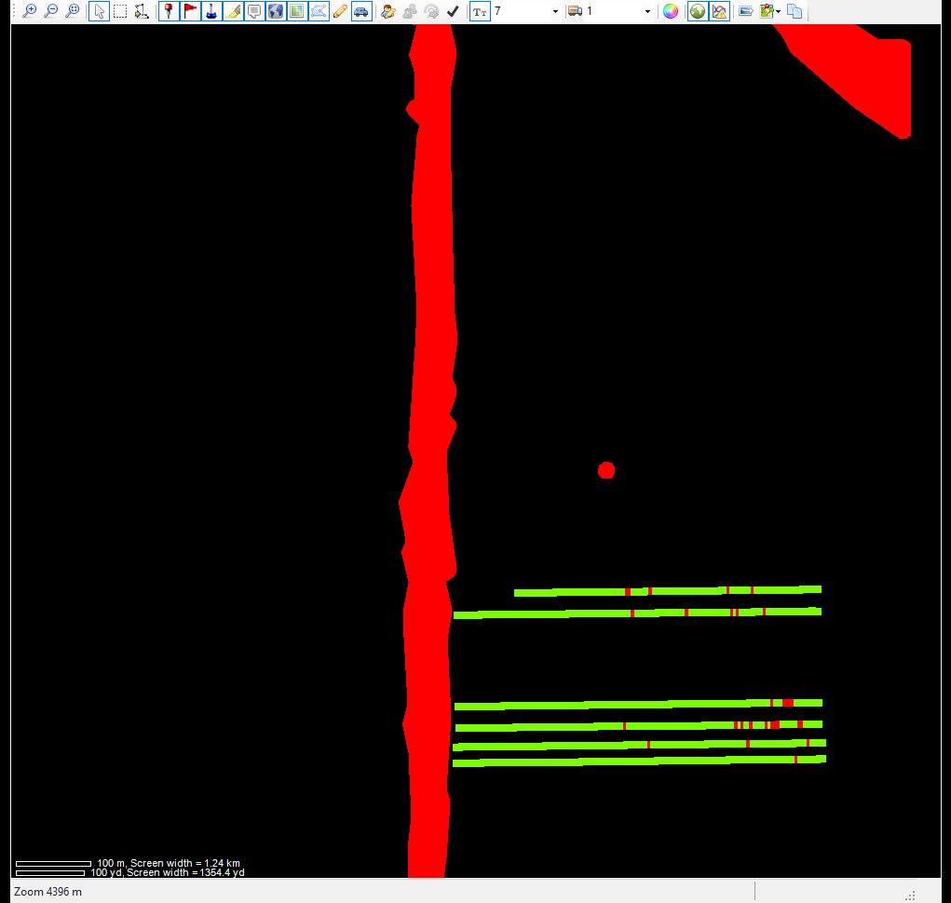
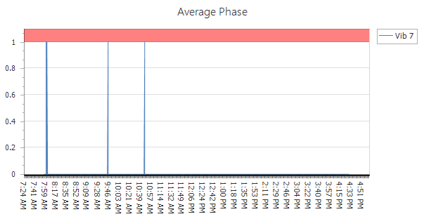
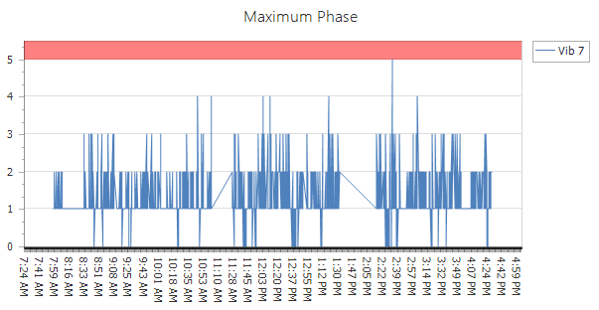
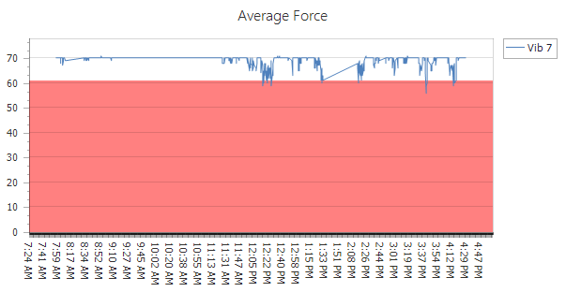
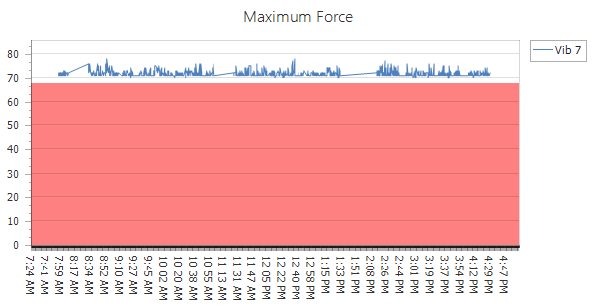
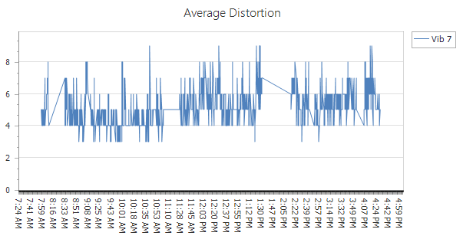
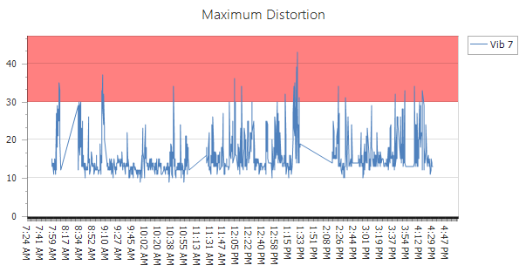
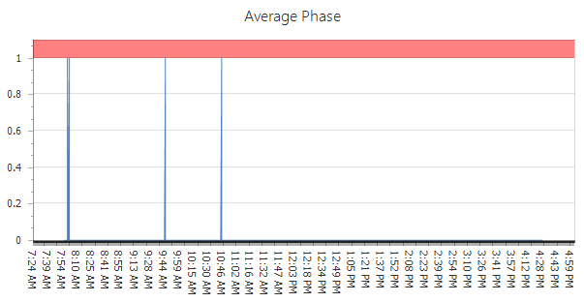
7
Vibrator
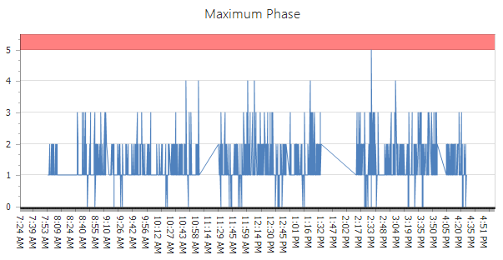
Phase Plots
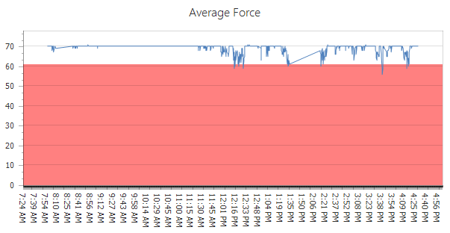
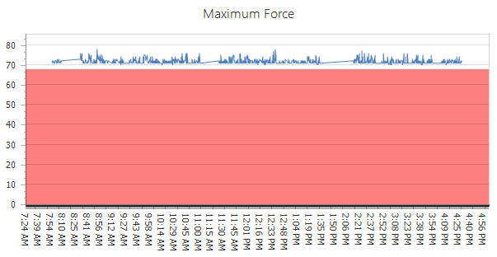
Force Plots
7
Vibrator
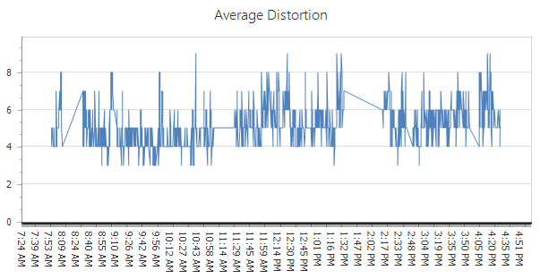
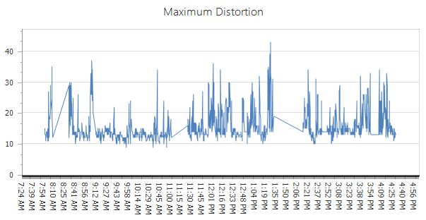
Vibrator
7
Distortion Plots

